Display model shown with optional electric corner fireplace
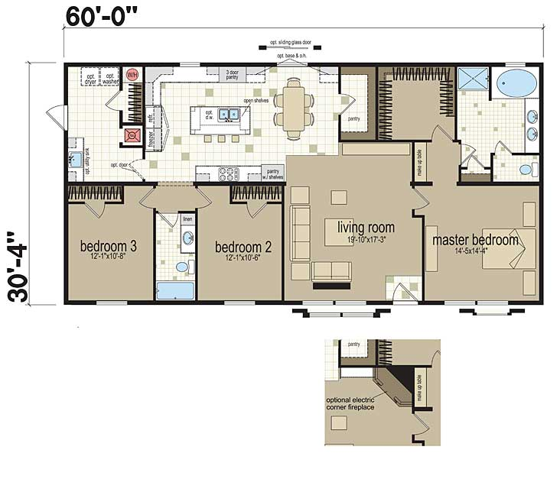
Display model shown with optional electric corner fireplace

